Lesson 2.3.4- First Impressions of Act I, Scene 2
English 12 Wakelet Link
Engage (pg. 2 in edio):
You might think of him as just a playwright from centuries ago, but many of the words and phrases you use every day were either invented by Shakespeare or popularized through his plays.
- Shakespeare had a creative, fearless approach to language. If the right word did not exist, he just made one up.
- Sometimes, he combined words, turned nouns into verbs, or changed how words were used.
As a result, he introduced more than 1,700 new words into the English language, and many of them remain today.
Words Created by Shakespeare:
- eyeball: Henry VI, Part 1, Act IV, Scene 7
- lonely: Coriolanus, Act IV, Scene 1
- questioning: As You Like It, Act V, Scene 4
- varied: Titus Andronicus, Act III, Scene 1
Comma Splices and Run-On Sentences (pg. 3 in edio):
Readers need signals, such as punctuation or connecting words, to know when one idea ends and another begins. In a previous lesson, you learned:
- A run-on sentence is when two or more complete sentences are combined without the correct punctuation or joining words.
- A common writing mistake is when a comma splice is used, or when two complete sentences are joined together with just a comma. This is a special type of run-on sentence.

Ways to Correct Run-On Sentences and Comma Splices
Use a period to separate the two independent clauses. | Incorrect example: The storm hit the ship, the passengers were terrified. | Correct Example: The storm hit the ship. The passengers were terrified.
Add a comma and a coordinating conjunction between the two independent clauses. | Incorrect example: Prospero was once the Duke of Milan he was overthrown by his brother. | Correct Example: Prospero was once the Duke of Milan, but he was overthrown by his brother.
Turn one of the independent clauses into a subordinating (dependent) clause. | Incorrect example: The storm hit the ship, the passengers were terrified. | Correct Example: Because the storm hit the ship, the passengers were terrified.
Use a semi-colon to separate the two independent clauses. | Incorrect example: Prospero was once the Duke of Milan he was overthrown by his brother. | Correct Example: Prospero was once the Duke of Milan; he was overthrown by his brother.

Bonus: Comma Splice and Run-On Extra Practice (Wayground Link)
Use the link or the QR code on page 3 of the lesson after class/completing the lesson to work through the Wayground extra practice activity to get some extra practice with run-on sentences and comma splices, and to earn 3 bonus points on today’s assignment.
- Remember to sign in with Clever and then sign in with edio if you a prompted to log in!

Words in Context (pg. 4 in edio):
Context Clues: Other words in a sentence or situation to figure out an unknown word’s meaning
Shakespeare invented and used many words in new ways. You do not necessarily need a dictionary to understand him. Just pay attention to what is happening in the scene or sentence.
- Example: Prospero. Thou most lying slave,/ Whom stripes may move, not kindness! (I.2.404-405)
  - Consider the word “stripes” in the excerpt. You might think of tigers or patterns, but in this context, Caliban is being threatened.
  - Here, “stripes” means a physical punishment, such as whipping, which leaves behind stripes across the skin.
Tips for Reading Shakespeare’s Plays:
- Read them aloud.
- Use context clues.
- Look up unfamiliar words.
- Enjoy them!
Characters and Motivations (pg. 5 in edio):
Authors communicate a character's unique traits, such as their personality, values, beliefs, and motivations, as they write a story.
- One way to develop a character is through dialogue, or what they say and how they respond.
In Scene 1 of The Tempest, the characters have not been fully developed yet, but you can figure out what drives their actions by analyzing what they say and how they respond to the danger.

Examples:
Boatswain | When the sea is. Hence! What cares these roarers for the name of king? To cabin: silence! Trouble us not.  (I.1.16-18) | Boatswain is the leader of the ship's crew, but he does not have power or nobility.  - In this excerpt, Boatswain explains that the sea does not care about the social rank of the people on the ship.  Motivation: survival over social status
Sebastian | A pox o’ your throat, you bawling, / blasphemous, incharitable dog!  (I.1.41-42) | Sebastian expresses his anger and frustration to Boatswain because he feels helpless.  - The storm is raging and Sebastian is fearful.  Motivation: Fear and Loss of Control

Comprehension Check:
Question | Answer
Which statement accurately describes Gonzalo's motivation?  Gonzalo. I have great comfort from this fellow: methinks he hath no drowning mark upon him; . . .  (I.1.29-30) | Gonzalo is motivated by optimism. He tries to comfort others and remain hopeful.

Act I, Scene I Recap (pg. 7 in edio):
- The play opens amidst a violent storm at sea. A ship carrying Alonso, the King of Naples, his son Ferdinand, his brother Sebastian, and Antonio, the Duke of Milan, is caught in the tempest.
- The ship’s crew, led by the Boatswain, struggles to keep the vessel afloat. The noble passengers panic and interfere with the sailors’ work, prompting the Boatswain to angrily tell them to stay out of the way.
- Despite their high status, the storm shows that nature does not discriminate—everyone is equally vulnerable. The scene ends with cries of despair as the ship appears to be sinking, setting a tone of chaos and fear.

Prepare to Read and Annotate (pgs. 6 & 7 in edio):
You can review the class annotation strategies by clicking the [+] button on the dropdown on page 6.
Remember to annotate every time you read. Annotating while reading helps you better understand the text.
You are only responsible for reading and annotating ACT I, SCENE 2 today.
Reading The Tempest Resources
Physical Copy | Pages 6-26
PDF of the Text | - edio- page 7  - Wakelet- Unit 2 Resources tab
Digital Notebook | edio- page 7
Brownsea Open Air Theatre Recording | - edio- page 7  - Wakelet- Unit 2 Resources tab

If you know you struggle with understanding Shakespeare, I HIGHLY recommend reading and annotating with the PDF of the text on your computer.
Today’s Annotation Focus:
- Find examples of each character's motivation and development throughout the scene.
  - Note what the character says (dialogue) and how the characters interact with one another.
Lines 1 to 59 (pg. 8 in edio):
- Read and annotate the section.
- Then, complete the activities on this page.
Character Motivation and Development:
- In this emotional and revealing scene, Prospero begins to explain his and Miranda’s past.
- The storm she just witnessed was not a natural disaster but one conjured by Prospero’s magic. While Miranda believes lives were lost, Prospero assures her no one was harmed.
- He begins to share the truth about their identities, revealing that he was once the Duke of Milan and that Miranda was born into royalty.
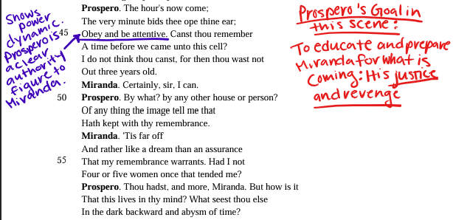
Lines 60 to 122 (pg. 9 in edio):
- Read and annotate the section.
- Then, complete the activities on this page.
In this part of the scene, Shakespeare slowly reveals more key pieces of Prospero’s backstory, helping the reader understand both his past experiences and present motivations.
What to Look For | Example From the Text | What It Reveals
Reactions and Questions | Sir, are not you my father? (I.2.66) | Miranda is curious and eager to understand her past, showing she's growing more aware of her identity.
How a Character Tells Their Story | . . . thy father / was Duke of Milan. . . (I.2.68-69) | Prospero carefully reveals his past, showing both pain and pride.  - He is motivated by a need to explain and justify his actions.
Emotional Language | . . . he was / The ivy which had hid my princely trunk . . . (I.2.100-101) | The strong metaphor expresses betrayal.  - This reveals Prospero’s long-held resentment and why he seeks justice.
Reactions to New Information | O, my heart bleeds . . . (I.2.77) | Miranda's empathy and emotional response show her maturity and her deepening understanding of her father’s suffering.
Repetition and Emphasis | I pray thee, mark me . . . Dost thou attend me? (I.2.79, 92) | Prospero’s urgency reveals how deeply the story affects him.  - He wants Miranda to truly listen and learn from it.

Lines 121 to 218 (pg. 10 in edio):
- Read and annotate the section.
- Then, complete the activities on this page.
When reading Shakespeare’s work, you know some words will be unfamiliar, but you can often figure out their meanings using strategies like context clues.
Examples
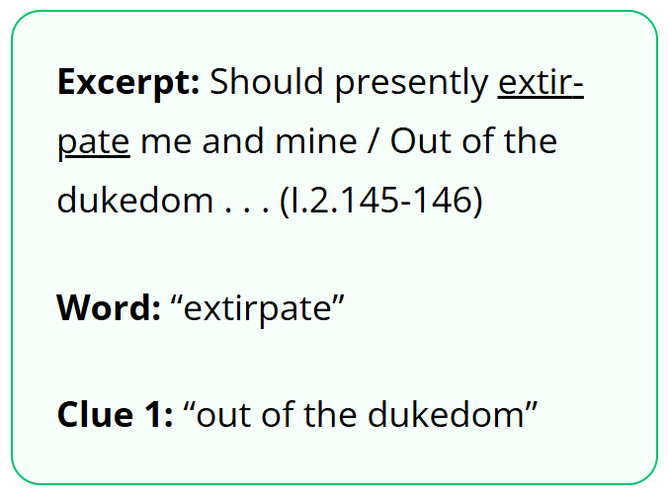 | Extirpate: to completely get rid of someone or something—like pulling it out by the roots.  - Antonio wanted to take over, and he wanted Prospero and Miranda to be removed.
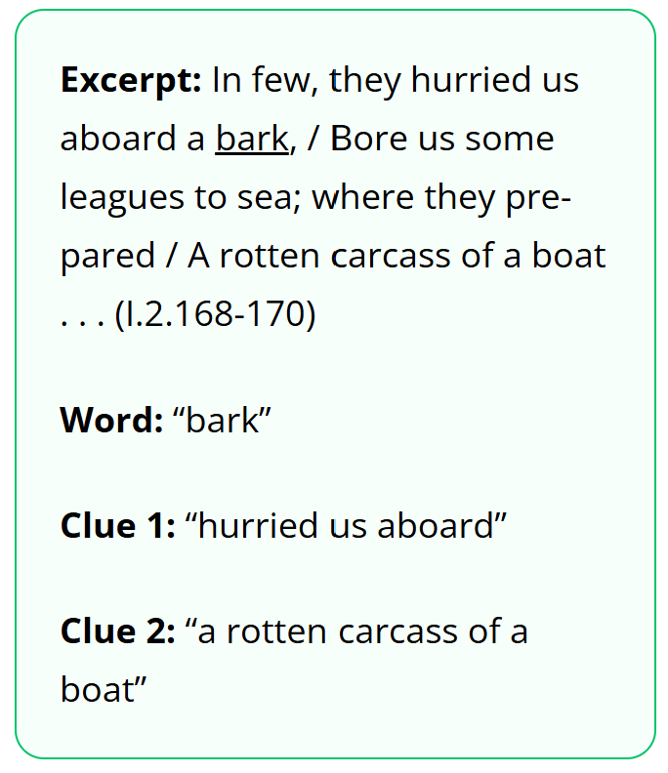 | Bark: a type of ship or sailing vessel.  - Prospero is describing how they were sent out to sea and mentions a boat right after which helps readers infer the meaning of the word
Comprehension Check:
Question | Answer
Based on the context and your knowledge of word parts, which of the options below is the best definition of "inveterate"?  - The King of Naples, being an enemy / To me inveterate, hearkens my brother's suit (I.2.141-142) | deep-rooted and long-standing

Show (pg. 11 in edio):
Run-On Sentence | Not a Run-On Sentence
Miranda was full of pity for the passengers, she did not know they were safe. | Caliban plotted against Prospero, and he believed the island should be his.
Ariel obeyed Prospero he used his magic to lead the others away.

Question | Answer
Based on the context and your knowledge of word parts, which of the options below is the best definition of "perdition"?  - So safely ordered that there is no soul— / No, not so much perdition as an hair/ Betid to any creature in the vessel (I.2.34-36) | harm or danger

Student Notes (Optional): Use the space below to record and organize your response to the short answer question on page 11 to look back at later.
What do these lines reveal about Prospero's motivation for creating the storm that caused the ship to sink?
- "Know thus far forth. By accident most strange, bountiful Fortune, Now my dear lady, hath mine enemies Brought to this shore; and by my prescience I find my zenith doth depend upon A most auspicious star, whose influence If now I court not but omit, my fortunes Will ever after droop." (Lines 207-214)
Sentence Starters:
- In these lines, Prospero reveals that his motivation for creating the storm was __________.
- He believes that __________ has brought his enemies to the island by chance, but he also sees it as an opportunity because __________.
- The phrase “_______________” suggests that __________.
- This shows that Prospero feels he must act now because __________.

